Assignment 5.2
Robert Breutzmann's CSD380 GitHub
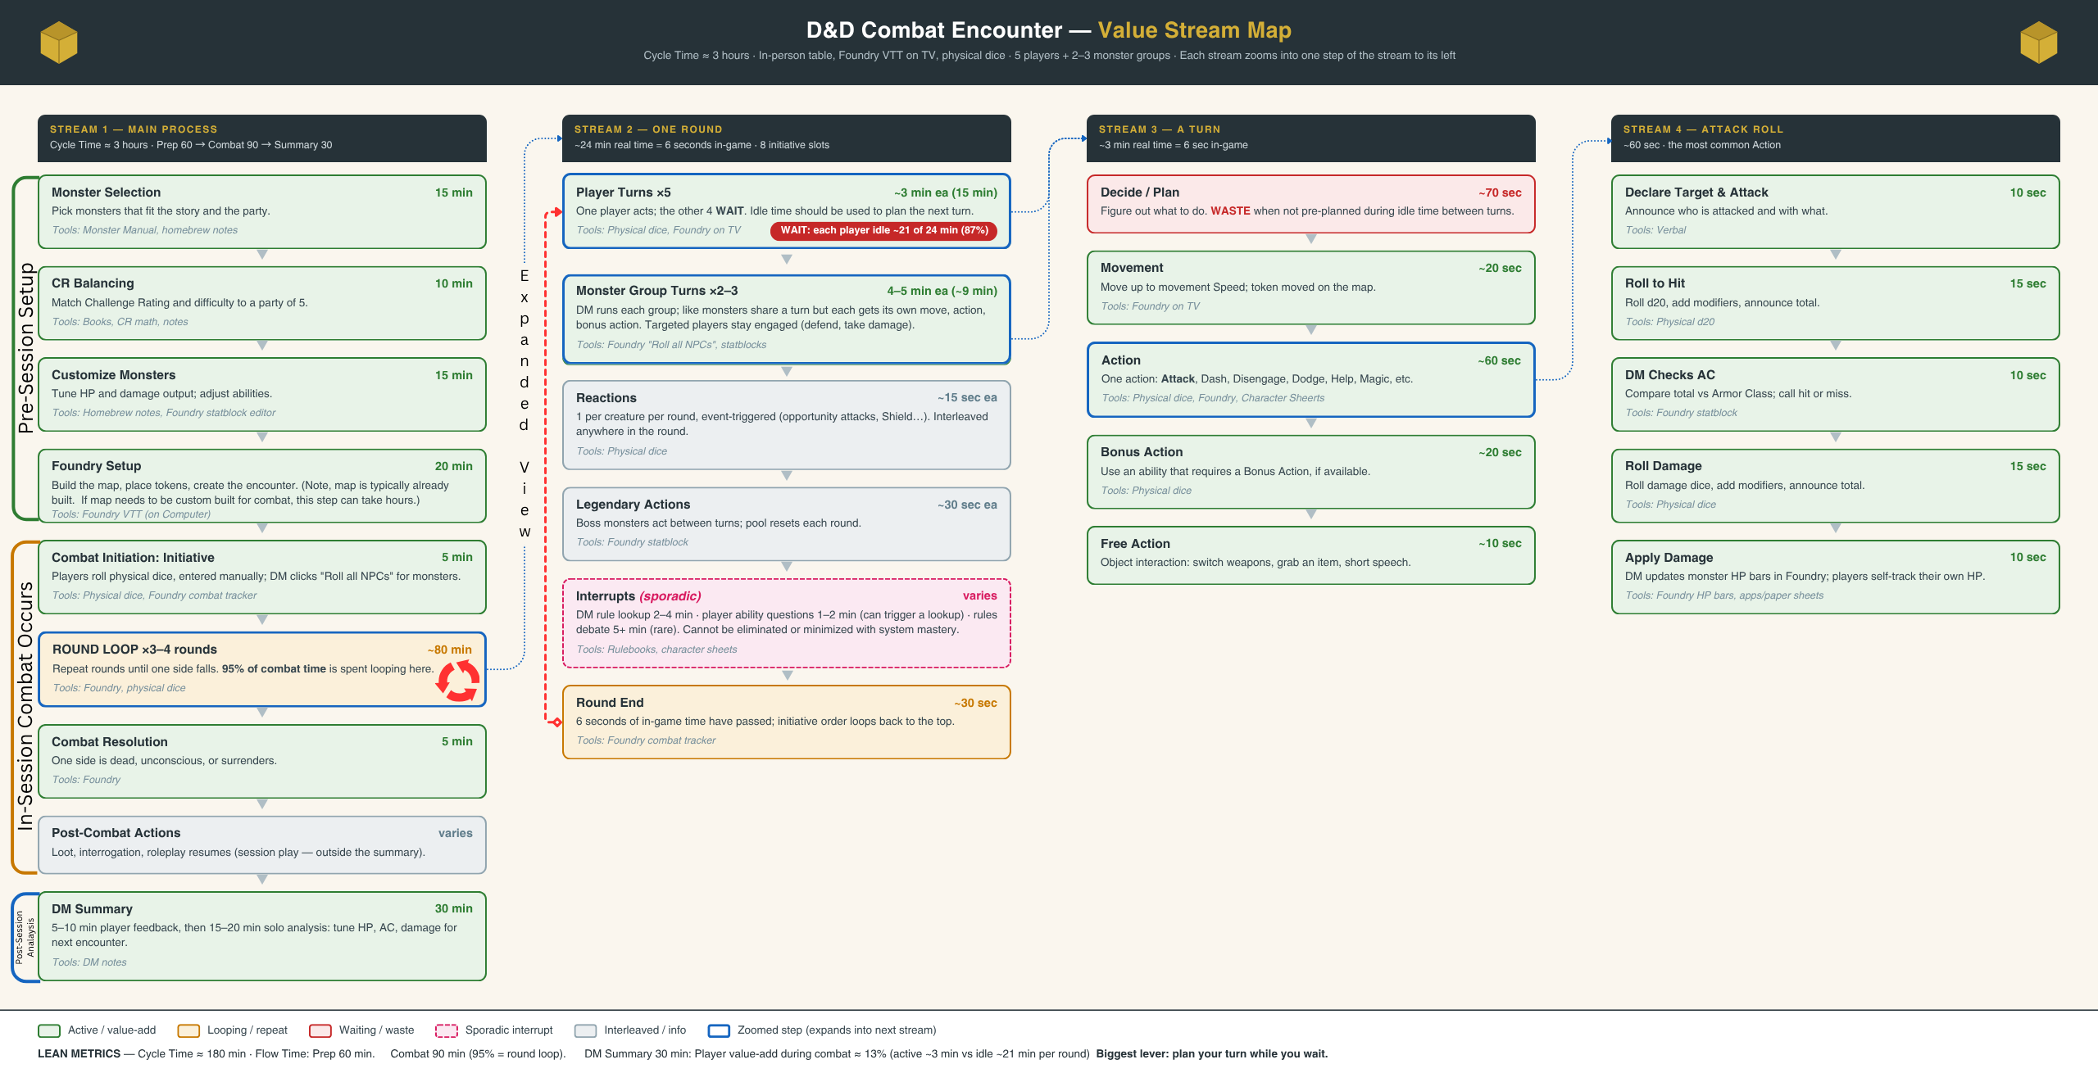

Value Stream Map Write Up

(Expanded Summary of the Graphic)
I decided to go with something I do regularly: designing and running Dungeons & Dragons encounters. There are several spots in the graphic that ended up quite large, so I attached the graphic itself to this assignment so you can see it better. The map shows the process of designing and running the encounter from beginning to end.
The first stream is the main overview. It starts with planning the encounter. This includes selecting the monsters the players will face and ensuring they are an appropriate challenge for their level and composition. There is a system called Challenge Rating that provides guidelines for balancing encounters; it is famous for not being very good, but it provides a good starting point. The monster selection is typically based on what part of the story the players will be interacting with. For example, in the last session, they were retrieving a stolen artifact from a bandit’s den, so they fought a large group of bandits (mostly thugs who sort of work together well with a couple who are “better,” commonly called lieutenants). After the monsters have been selected, a quick CR calculation is done to determine how “deadly” the encounter is, and I weigh this against how easy I want the encounter to be (sometimes they should breeze through an encounter, other times they should face a legitimate challenge). Next, I tweak the monsters' abilities and equipment to better match the difficulty level I want or give them a magic item to play with (knowing it will end up in the players' hands when they win). Once the encounter is balanced the way I want, I find the monsters in Foundry, place them on the virtual table with the players, and add them all to the combat tracker, so it is ready to go when combat starts.
The second stream is the Combat Sequence in the game. When combat begins, we roll initiative. For all non-player-controlled characters, there is a button on Foundry I can press that auto-rolls their initiative, then I get each player’s roll (they all roll physical dice) one by one. Then, going down the initiative order, each player and monster takes their turn. Player turns typically take 3-6 minutes, depending on the player. For some players, their abilities simply take longer to resolve, but for others, there is additional time spent planning and figuring out what their abilities do. The monster turns (and monsters are typically grouped into “like monsters”, for example, 10 bandits go as one group) are typically much faster because I have pre-planned what their motivation is for this encounter, and only have to readjust when the players really throw a curveball. Some monsters have what are called Legendary Actions, which resolve between turns. This is meant to simulate a monster that is a high threat, being able to take extra actions so as to negate what is commonly called the “action economy advantage” of having 4-5 players take a turn and attack while the monster only gets 1 (essentially turning a monster into a “boss monster,” making it very deadly). One thing to add here, which I put towards the end, is that there are typically interruptions to the process: players asking questions about their abilities or trying to remember something that was said or done earlier. Sometimes they need clarification on a rule or don’t understand how something works. Occasionally (this happens very rarely), a disagreement or debate over a rule can stop the game entirely. The issue here is that while a player is idle for over 75% of the time during combat, the Dungeon Master is always active. So when the dungeon master gets pulled to the side for a sidebar, combat stops until that can be resolved.
The third stream shown is each player’s (or monsters’) turn. Each segment can take place in any order and can even be broken up and split into two (for example, an action might include 2 attacks, and a player is allowed 30 feet of movement, so they move 10 feet, attack once, move 10 more feet, attack again, then move 10 more feet, splitting their movement into 3 and attack action into 2. The player or monster gets movement, an action, a bonus action, and a free action. The action is typically the longest, as it involves rolling dice and calculating the result, which is why the last value map I drew was the attack action (though it applies to most actions that require a 2-phase roll).
In the last stream, I mapped an attack action. For an attack action, the player rolls to attack, adding any modifiers. That number is then compared against the defender’s Armor Class (AC), and if it is higher, the attack hits. The player then rolls damage based on the attack, and that much damage is dealt to the defender. Most of the time, players roll the attack and only roll the damage when the attack hits. If the attack misses, the action ends with no damage (except under a certain circumstance I will bring up later.

Lean Metrics:
So, where does the time go? How long does combat take, and what can be done to shorten it?
- Pre-Session: approx. 1 hour (or 2-4 for a custom monster, 2-3 hours for a custom map, or 5-8 for both).
  - Monster Selection: 15 minutes (Homebrew monsters can take 1-3 hours to brew up, depending on complexity)
  - CR Calculations: 10 minutes
  - Monster Customizing/CR Tweaks: 15-20 minutes
  - Foundry Setup: 20 minutes (1-2 hours added if a custom map needs to be built for the encounter)
- In Session Combat: (Varies based on number of rounds, which is typically around 3-4, but typically approx. 2 hours)
  - Roll Initiative, Setup Turn Order in Foundry: 5 minutes
  - Player Turns (5 per round): Approx 5 minutes each
    - Attack Action: Approx. 45-60 seconds
      - Roll Attack, Add modifiers: 15 seconds
      - Check against Monster AC, see if hit or miss: 5 seconds
      - IF hit, roll damage dice, and add modifiers: 15-30 seconds
      - Apply damage modifiers (resistance): 5 seconds
      - Apply damage to monster/character hit points: 5 seconds
  - Monster Turns (2-5 per found): Approx 3 minutes each
  - Reactions and Legendary Actions (sporadic): Approx 2-5 minutes per round total
  - Interruptions (Very sporadic and unpredictable): can be 1-10 minutes per interruption, depending
- After Session Ends: Approx. 30 minutes
  - Discuss combat with players: 5 minutes
  - Analyze monster weaknesses and strengths, figure out where strategies/stats failed: 25 minutes

Where is the Waste?
Player Idle Time: On-Turn Deciding Time
It became obvious to me that there are a couple of places where waste occurs. The most obvious is when a player hasn’t figured out what their plan is in the 25 minutes of a round of combat that wasn’t their turn. As a DM, I am always a part of the action, but a player is idle for a large part of it. They are occasionally drawn in when attacked or needed for making a saving throw against an event, but they can be planning what their next move is going to be, or even planning with another player while others are busy taking their turn. So, being ready for their turn is a big boost to how fast combat runs (it eliminates about 1-2 minutes at the start of the turn, where they are trying to figure out what to do). Of course, as a bunch of neurodivergent people sitting at a table, it can be hard to stay “tuned in,” so a trick I learned to help players focus and get a plan in place before their turn starts is to do this: “Rhogar, you’re up. Liliana, you’re on deck.” This “wakes them up” and makes them pay attention and analyze the table, and eliminates a lot of that planning time.
When Two Rolls Can Become One Roll
Another one that stuck out to me is when a player needs to roll to attack and deal damage; time gets wasted with rolling twice. Most players use dice towers and “shake dice” in their hands or have some other “ritual” when it comes to rolling, so it isn’t instant. If they roll dice together, they can have the damage roll already done in the event an attack hits, saving about 5-10 seconds of that time. This doesn’t seem like a lot, but if you consider that anywhere between 20 and 100 attacks happen in any given combat session, that becomes 60-1000 seconds saved (and probably averages out to something closer to 5-6 minutes saved).
Rules Frictions
When it comes to D&D, player abilities (especially ones that don’t get used a lot) can be confusing. It’s inevitable that there will be questions. This is why I make it a point to try to understand everything about the player characters’ abilities so I can answer these questions. But there should also be some ownership on the players’ part in understanding their own abilities. Most of the time, this is 10 seconds of “yes, that’s how that works.” But sometimes there is a serious misunderstanding. This leads to the rule of “The DM has the final say, and disputes will be resolved AFTER the session.” The idea is that we don’t want to slow down the session, as combat can already be a slog… So, if something bogs us down in a rules debate or fight…. DM rules, figure out what the real answer is later, and go from there. No rules debate should last longer than 1-2 minutes.
Prep-Time: Crafting Monsters Twice:
Something else was causing waste that came up for me as part of this assignment. When I craft a monster, I use an AI tool to help me fill in details, generate an image (mostly for a token), and customize abilities (which I then usually tweak to better match the vision I have for the monster). This is crafted as a Markdown file in my world notes in Obsidian, where it links to the rest of my world notes. Then I must craft the monster AGAIN in Foundry (mostly copy-paste from Obsidian). However, I realized I could craft a custom importer, using my programming knowledge, to craft an importer that can parse my markdown file (which is built in a template) to allow me to simply import the file out of my vault, and it fills in all the stats, abilities, equipment, etc. Saving about 20 minutes of the prep of the monster!

